Reading
Excerpt from a comic book to help Indonesian Muslims prepare for the hajj, with information ranging from formal religious rituals to advice on ‘Arab customs.’ A. Luqman, Cara Mabrur Naik Haji dan Umrah. Jakarta: Nirmana, 2000, pp. 100-101.
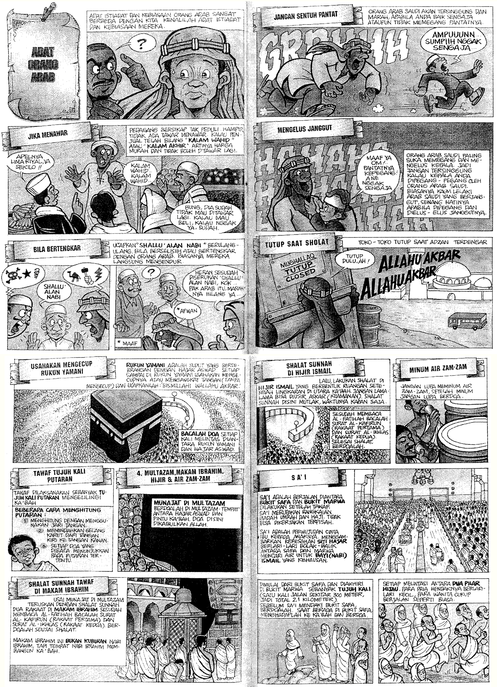

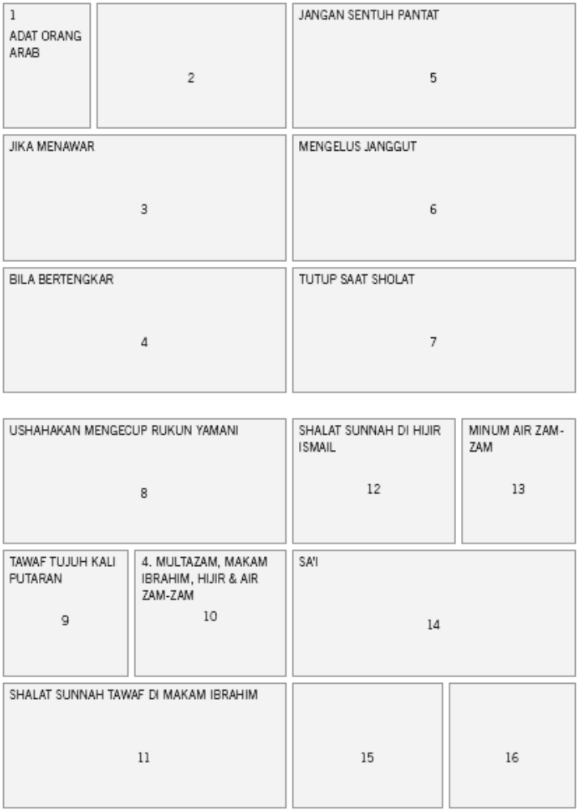

Translation by James Wilson.
FRAME | TRANSLATION
1 | Title of cartoon: Arab Culture
2 | The traditions and habits of Arabs are very different from ours. Please get to know their habits and traditions.
3a | Title: “If negotiating prices”
3b | Text: Merchants have an “I could care less” attitude; they almost never bargain. If the seller says “Kalam Wahid” or “Kalam Akhir” it means the price is already cheap and don’t haggle anymore.
3c | Quotes:  Far left: “How about 5 Riyals per kilo for the apples?”  Far Right: “Brother, he already said no more bargaining. If you’re going to buy then buy. If not, then leave it.”
4a | Title: “If Arguing”
4b | Text: Say “Shallu’alan Nabi” repeatedly if arguing or bickering with an Arab.  Usually they will immediately back off.
4c | Quotes: “Afwan” Arabic for maaf, meaning “please forgive me”  Woman on right: “Surprising—you shouted ‘Shallu’alan Nabi’ and that Arab’s anger just disappeared!”
5a | Title: “Don’t touch their butt”
5b | Text: “Saudi Arabians get insulted and angry when you touch their butt, whether on purpose or by accident.
5c | Quote: “I’m sorry, I swear it wasn’t on purpose.”
6a | Title: “Stroking the Beard”
6b | Text: Saudi Arabians really like to touch or pat peoples’ heads. Don’t get insulted if your head keeps getting touched by Saudi Arabians. Usually Arab men have a long beard, and it gives them pleasure when it’s stroked or touched.
6c | Quote: “Excuse me, uncle, I touched your butt by accident.”
7a | Title: “Closed at the time of Sholat”
7b | Text: Stores close when the call to prayer is heard.
7c | Quote:  Merchant: “Closed for now!”  From the Mosque: “God is greater than…”
8a | Title: “You need to kiss the Rukun Yamani”
8b | Text: Rukun Yamani is the corner opposite the Hajan Aswad. Each time you  arrive in the Rukun Yamani you must kiss it (the Hajan Aswad) or raise  your hands (without kissing) and say: Bismallahi Wallahu Akbar.
9a | Title: “Tawaf 7 times around”
9b | Text: The ritual called Tawaf is executed by walking around the perimeter of the Ka‘ba seven times. There are several ways to count the number of times you circle the Ka‘ba:  1. Count with the fingers of your right hand  2. Move a rubber bracelet from your left hand to your right hand.  3. Each prayer that is read shows that one circumambulation has been completed.
10a | Title: “Multazam, Abraham’s Grave, Hijir [see 12b, below] and the Water from the Sacred Well”
10b | Text: Offering your desires at Multazam: Pray in the Multazam, which is the place between Hajar Aswad and the door of the Ka‘ba. Allah will grant prayers made here.
11a | Title: Additional, optional prayers and circumambulations around Abraham’s grave.
11b | Text: After offering your desires at Multazam, continue to with additional, optional prayers and two prayer units at Abraham’s grave. After reading Al-Fatihah, read the epistle of Al-Kafirun (first prayer unit) and the epistle of Al-Ikhlas (second prayer unit). Offer personal prayers after these ritual prayers. The grave of Abraham is not where the Prophet Abraham is actually buried, but is the place where the Prophet Abraham built the Ka’ba.
12a | Title: “Additional, optional prayers in the Hijir Ishmael”
12b | Text: Later, pray in the Hijir Ishmael, which is the space in the middle of the fenced in area to the north of the Ka‘ba. Don’t take too long or you’ll be chased out by the “unofficial” security, but additional prayers can be made here at any time, without special requirements. After reading Al-Fatihah, read the epistle of Al-Kafirun (first prayer unit) and the epistle of Al-Ikhlas (second prayer unit). Finish these ritual prayers, and then offer your personal prayers.
13a | Title: Drink the water from the Sacred Well.
13b | Text: Don’t forget to drink the water from the Sacred Well, and after drinking don’t forget to pray.
14a | Title: “Sa’i”
14b | Text: The ritual called Sa’i is executed by walking between Safa Hill and Marwa Hill after having performed Tawaf. Sa’i is like a series of prayers and offerings to God; it is like a pilgrimage. Sa’i is the result of a mother’s love for her child. It represents the anxiety of the servant Hajar running back and forth between these two hills carrying water for the infant Prophet Ishmael when he was dying of thirst.
15 | Run beginning at Safa Hill and ending at Marwa Hill seven times (each time is  about 300 meters, for a total of 2.1 kilometers). Pray before embarking from  Safa Hill. Each time you’re back at Safa Hill, turn toward the Ka‘ba and pray.
16 | Each crossing between the two green pillars, the intention is for men to jog,  while for women it is enough to walk normally.

These are Arabic phrases the reader is being informed to listen for.
Saudi currency
In Indonesian, this is a common term showing camaraderie, and it does not necessitate familial relation.
An Arabic phrase.
A common term of endearment in Indonesian for a man older than the speaker who has, or could have, an avuncular relationship with the speaker; it does not necessitate familial relation.
The humor in this frame is that the Arab is deriving such pleasure from having his beard stroked that he doesn’t notice that the child touched his butt.
Sholat are Islam’s ritual prayers conducted at particular times and marked by specific recitations and prostrations.
The Indonesian word Rukun is used here both in the physical and metaphysical sense: it can mean a pillar, a ritual obligation (as in the Five Pillars of Islam), or “harmonious” (as in the harmony that upholding such pillars of faith can create). This frame discusses a ritual obligation conducted in a particular space, the Rukun Yamani, which contains the “pillar” of the Hajar Aswad (see footnote 9 below) in the great Mosque of Mecca.
Hajan Aswad is corruption of the Arabic al-Hajar al-Aswad, which is the Black Stone of God. A meteorite considered sent by Allah and originally erected at Mecca by the Prophet Abraham and his son, the Prophet Ishmael.
An Arabic phrase of worship.
The cubical shrine at the center of the Great Mosque.
Sunnah are ritual prayers (Sholat) that are not performed or required at particular times of the day, but may be done at any time.
Rakaat are the individual prayer units marked by a specific reading followed by ritual prostration like those performed during Sholat.
This is the sacred well of Hajar, slave of the Prophet Abraham and the mother of his son, the Prophet Ishmael. This well is located inside the Great Mosque at Mecca.

